**Lab Assignment 02**

**Name** : Md. Tasnimul Hassan Khan Rafath

**Student ID** : 21201452

**Section**  : 07

**MYSQL Commands**

create table Employee (employee_id char(10), first_name varchar(20), last_name

varchar(20), email varchar(60), phone_number char(14), hire_date date, job_id char(10), salary int, commission_pct decimal(5,3), manager_id char(10), department_id char(10));

insert into Employee values ('EMP001','Harry','Granger','wizard@gmail.com','0192345002','2020-6-10','JOB001',45000,25.789,'MNG001','DPT001'),('EMP002','Draco','Malfoy','malfoy@gmail.com','0192345001','2020-6-9','JOB002',95000,40.789,'MNG002','DPT002'),('EMP003','Severus','Snape','halfbloodprince@gmail.com','0192345003','2020-5-10','JOB003',25000,85.765,'MNG003','DPT003'),('EMP004','Hermione','Granger','granger@gmail.com','0192345004','2020-6-11','JOB004',85000,78.934,'MNG004','DPT004'),('EMP005','Ron','Weasley','ronald@gmail.com','0192345006','2020-6-7','JOB005',60000,63.037,'MNG005','DPT005'),('EMP006','Tom','Riddle','darklord@yahoo.com','0192345005','2020-9-12','JOB006',100000,99.999,'MNG006','DPT006'),('EMP007','Neville','Longbottom','braveheart@hotmail.com','0192345007','2020-12-4','JOB007',45000,75.849,'MNG007','DPT007'),('EMP008','Luna','Lovegood','loonylovegood@gmail.com','0192345009','2020-10-5','JOB008',75000,35.809,'MNG008','DPT008'),('EMP009','Sirius','Black','bestgodfather@hotmail.com','0192345010','2020-3-7','JOB009',90000,60.643,'MNG009','DPT005'),('EMP010','Cedric','Diggory','diggory.cedric@gmail.com','0192345008','2020-9-20','JOB010',25000,15.962,'MNG010','DPT007'),('EMP011','Ginny','Weasley','ginny.weasley@gmail.com','0196483078','2021-6-7','JOB011',15000,70.003,'MNG011','DPT009');

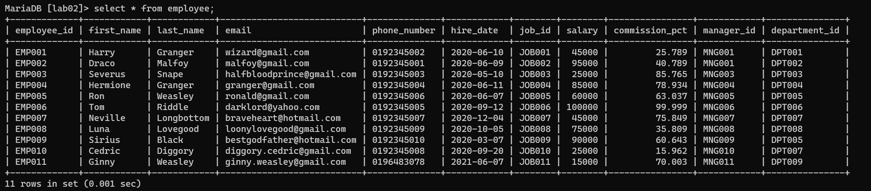

**Task 01:--------**

select first_name, last_name, email, phone_number, hire_date, department_id from Employee

where hire_date=(select max(hire_date) from Employee);

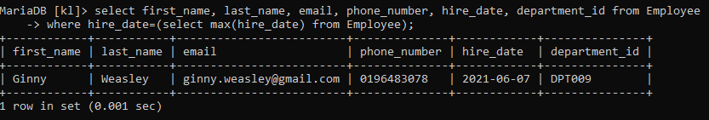

**Task 02:--------**

select first_name, last_name, employee_id, phone_number, min(salary),department_id from

Employee group by department_id;

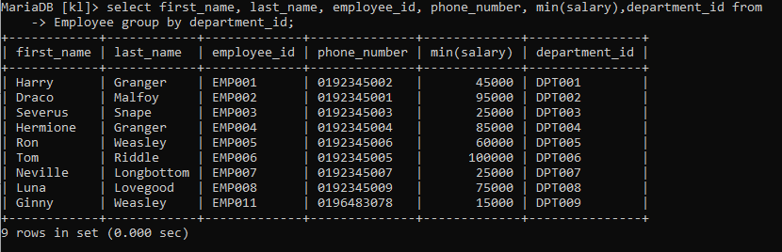

**Task 03:--------**

select first_name, last_name, employee_id, commission_pct, department_id from employee where department_id = 'DPT007' and commission_pct < all(select commission_pct from employee where department_id = 'DPT005');

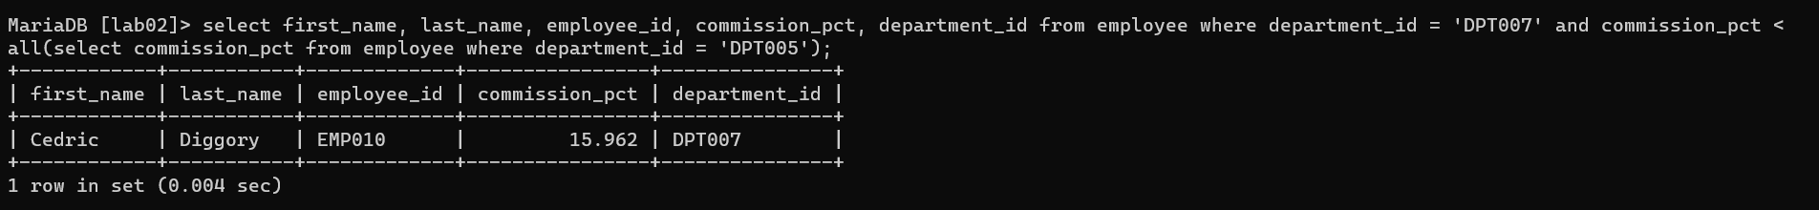

**Task 04:--------**

Select department_id, count(*) as total_employees from employee e1 where not exists (Select employee_id from employee e2 where e2.department_id = e1.department_id and e2.salary > 30000) Group by department_id;

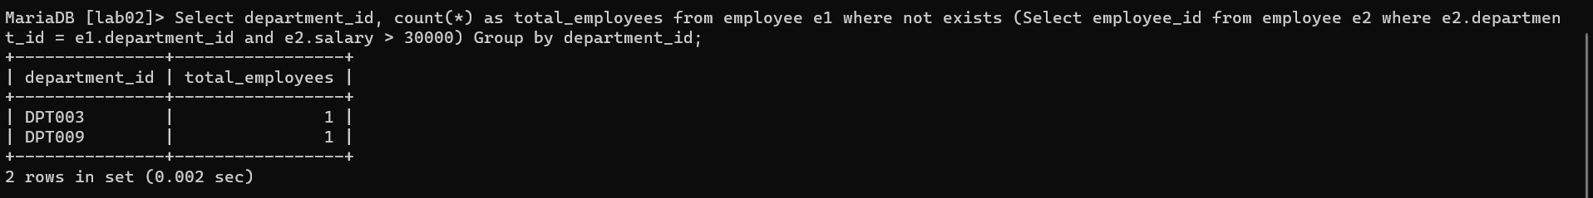

**Task 05:--------**

select department_id, job_id, commission_pct from Employee r1 where exists(select * from

Employee r2 where r1.department_id = r2.department_id and r1.job_id != r2.job_id and

r1.commission_pct < r2.commission_pct);

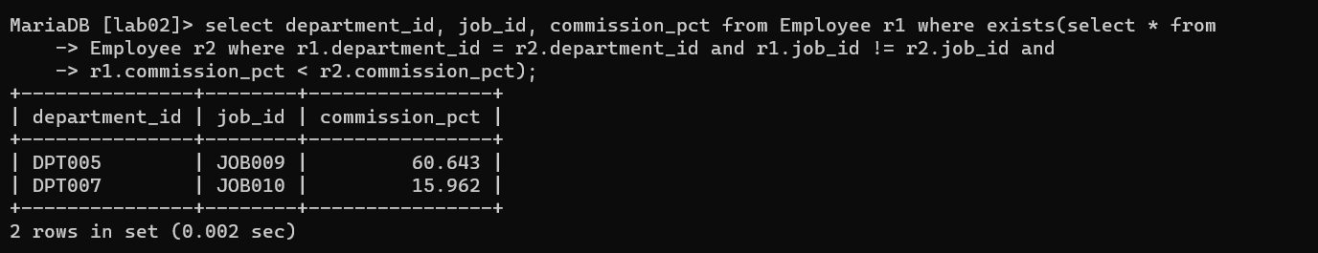

**Task 06:---------**

Select distinct manager_id from Employee where salary > 3500;

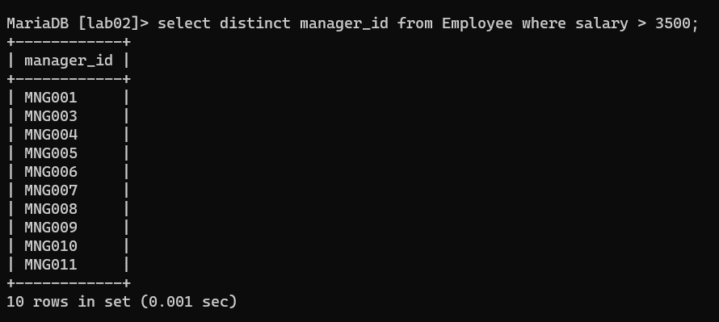

**Task 07:---------**

select first_name, last_name, employee_id, email, salary, department_id, commission_pct from

Employee group by manager_id having min(commission_pct);

